Lab Assignment: Inference for Paired Data

Christian Acosta

June 20th, 2016

## Exercise 1

To reduce ankle injuries, restrictive appliances such as taping and spatting (applying tape over the shoe and sock) have been employed. As part of a study at UWL, subjects also completed a 5-point Likert-type scale survey regarding their perceptions of the movement of each ankle appliance during exercise.

Researchers would like to compare the central values for perceptions of the movement of taped ankles compared to spatted ankles using $α=0.10$ and to estimate the difference with 90% confidence.

### Part 1a

Load the data set AnkleMovement.rda (in DS705data package)

### -|-|-|-|-|-|-|-|-|-|-|- Answer 1a -|-|-|-|-|-|-|-|-|-|-|-

data(AnkleMovement)  
head(AnkleMovement)

## tape spat  
## 1 3 2  
## 2 3 3  
## 3 2 4  
## 4 4 2  
## 5 4 2  
## 6 2 2

attach(AnkleMovement)  
AnkleMovement

## tape spat  
## 1 3 2  
## 2 3 3  
## 3 2 4  
## 4 4 2  
## 5 4 2  
## 6 2 2  
## 7 3 3  
## 8 3 3  
## 9 3 4  
## 10 4 4  
## 11 3 3  
## 12 4 2  
## 13 4 3  
## 14 3 3

#14 data points.

### Part 1b

Create a new variable of the differences, with the perceptions of the spatted ankle (spat) subtracted from the perceptions of the taped ankle (tape).

### -|-|-|-|-|-|-|-|-|-|-|- Answer 1b -|-|-|-|-|-|-|-|-|-|-|-

diff <- tape - spat  
diff

## [1] 1 0 -2 2 2 0 0 0 -1 0 0 2 1 0

### Part 1c

Create a boxplot and histogram for the sample of differences.

### -|-|-|-|-|-|-|-|-|-|-|- Answer 1c -|-|-|-|-|-|-|-|-|-|-|-

par(mfrow=c(1,2))  
boxplot(tape)  
boxplot(spat)

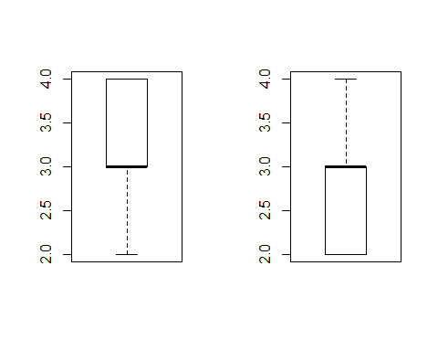

hist(tape)  
hist(spat)

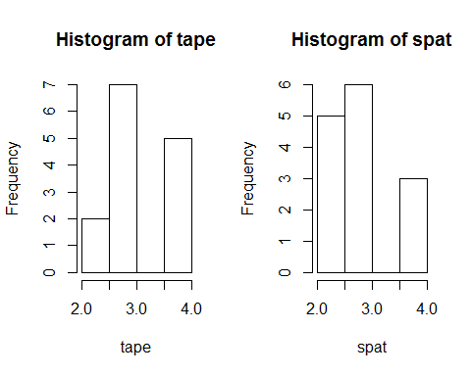

#Very hard to tell if they have normal variance or comes from normal data.   
  
sd(tape)

## [1] 0.6992932

sd(spat)

## [1] 0.7703289

boxplot(diff) #outliers. Boxplot looks weird with median at third quartile.   
hist(diff) #hist tough to tell if 'normally' distributed.

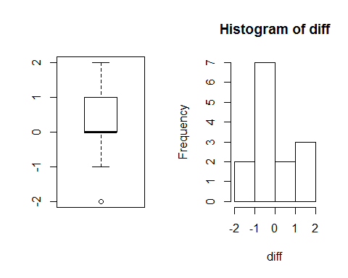

### Part 1d

Comment on the suitability of this data for the paired t-test, the Wilcoxon signed rank test, and the sign test.

### -|-|-|-|-|-|-|-|-|-|-|- Answer 1d -|-|-|-|-|-|-|-|-|-|-|-

To determine if the t-test or Wilcoxon should be used, we'll need to look into Variance and Normality. For the sign test, that could be completed using the +/- differential stored in the variable 'diff.'

### Part 1e

Because the choice of test is somewhat unclear, as happens often in real life, try all three tests to compare the central values for subject's perceptions of the movement of taped ankles compared to spatted ankles using $α=0.10$.

Do the t-test first:

#### Step 1

Define the parameter in words in the context of the problem.

#### -|-|-|-|-|-|-|-|-|-|-|- Answer 1e.step1 -|-|-|-|-|-|-|-|-|-|-|-

A paired unpooled t-test will be used to compare the difference in means between tape and spat. It will be unpooled to despite the standard deviations being close because of the small sample sizes.

#### Step 2

State the null and alternative hypotheses for the test.

#### -|-|-|-|-|-|-|-|-|-|-|- Answer 1e.step2 -|-|-|-|-|-|-|-|-|-|-|-

Null Hypothesis: There is no difference in means between tape and spat. Alternative Hypothesis: The means between tape and spat are different.

#### Step 3

Use R to generate the output for the test you selected.

#### -|-|-|-|-|-|-|-|-|-|-|- Answer 1e.step3 -|-|-|-|-|-|-|-|-|-|-|-

t.test(tape, spat, paired = TRUE, conf.level = 0.9)

##   
## Paired t-test  
##   
## data: tape and spat  
## t = 1.1613, df = 13, p-value = 0.2664  
## alternative hypothesis: true difference in means is not equal to 0  
## 90 percent confidence interval:  
## -0.1874990 0.9017847  
## sample estimates:  
## mean of the differences   
## 0.3571429

#### Step 4

State a statistical conclusion at $α=0.10$ and interpret it in the context of the problem.

#### -|-|-|-|-|-|-|-|-|-|-|- Answer 1e.step4 -|-|-|-|-|-|-|-|-|-|-|-

Conclusion: DO NOT Reject null hypothesis at alpha = .10. There is not enough evidence to show that the population mean (effectiveness) of taped ankles and the population mean of spatted ankles are different (p=.27).

#### Step 5

Write an interpretation in the context of the problem for the 90% CI for the population mean difference.

#### -|-|-|-|-|-|-|-|-|-|-|- Answer 1e.step5 -|-|-|-|-|-|-|-|-|-|-|-

At the 90% confidence interval, there is not enough evidence to suggest that the population means between spatted and taped ankles are different.

#### Step 6

Do the Wilcoxon Signed Rank Test. Show just your R code and the conclusion.

#### -|-|-|-|-|-|-|-|-|-|-|- Answer 1e.step6 -|-|-|-|-|-|-|-|-|-|-|-

wilcox.test(tape, spat, conf.int=TRUE, paired = TRUE, conf.level = 0.90)

## Warning in wilcox.test.default(tape, spat, conf.int = TRUE, paired =  
## TRUE, : cannot compute exact p-value with ties

## Warning in wilcox.test.default(tape, spat, conf.int = TRUE, paired =  
## TRUE, : cannot compute exact confidence interval with ties

## Warning in wilcox.test.default(tape, spat, conf.int = TRUE, paired =  
## TRUE, : cannot compute exact p-value with zeroes

## Warning in wilcox.test.default(tape, spat, conf.int = TRUE, paired =  
## TRUE, : cannot compute exact confidence interval with zeroes

##   
## Wilcoxon signed rank test with continuity correction  
##   
## data: tape and spat  
## V = 20.5, p-value = 0.2981  
## alternative hypothesis: true location shift is not equal to 0  
## 90 percent confidence interval:  
## -0.5000113 2.0000000  
## sample estimates:  
## (pseudo)median   
## 0.9999682

Conclusion: Do NOT reject the null hypothesis that the difference in medians is zero (alpha = .1). There is not enough evidence to suggest that the medians are different (p = .30)

At the 90% confidence interval, there is NOT enough evidence to suggest that the population medians are different between spatted and taped ankles using the Wilcoxin test.

#### Step 7

Do the sign test. Show just your R code and the conclusion.

#### -|-|-|-|-|-|-|-|-|-|-|- Answer 1e.step7 -|-|-|-|-|-|-|-|-|-|-|-

require(signmedian.test)

## Loading required package: signmedian.test

## Warning: package 'signmedian.test' was built under R version 3.1.3

signmedian.test(diff, mu=0, conf.level = 0.90, conf.int = TRUE)

##   
## Exact sign test  
##   
## data: diff  
## #(x!=0) = 7, mu = 0, p-value = 0.4531  
## alternative hypothesis: the median of x is not equal to mu  
## 87.5 percent confidence interval:  
## -1 2  
## sample estimates:  
## point estimator   
## 0

Conclusion: There is not enough evidence to reject the null hypothesis that the difference in medians between spatted and taped ankles is zero (alpha = .1, p-value: 0.45) using the sign test.

There is not enough evidence to build a confidence interval for the difference in medians.

#### Step 8

Compare the results of the three hypothesis tests.

#### -|-|-|-|-|-|-|-|-|-|-|- Answer 1e.step8 -|-|-|-|-|-|-|-|-|-|-|-

None of the three tests were conclusive. The sign test came back with the highest p-value, followed by signed rank and the paired t-test. The t-test's p-value was slightly lower (.27 vs .30) than the signed rank's value.

## Exercise 2

One hundred and twenty apparently healthy subjects volunteered to participate in this investigation. All subjects completed pre- and post-tests measuring lumbar strength, and the treatment group trained on the BackUpâ¢ Lumbar Extension Dynamometer (1 set of 20 reps twice per week) for 10 weeks.

Researchers would like to compare the central values for the pre- and post-training measurements for lumbar strength at $α=0.05$ and estimate the increase in lumbar strength with 95% confidence.

### Part 2a

Load the data BackUp.rda (in DS705data package)

### -|-|-|-|-|-|-|-|-|-|-|- Answer 2a -|-|-|-|-|-|-|-|-|-|-|-

data("BackUp")  
head(BackUp) #pre, post

## pre post  
## [1,] 245.7840 168.87638  
## [2,] 144.0731 225.14556  
## [3,] 165.5031 123.49595  
## [4,] 230.7129 143.67957  
## [5,] 165.3483 166.59780  
## [6,] 709.6411 83.63855

backs <- as.data.frame(BackUp)  
attach(backs)

### Part 2b

Create a new variable of the differences, with the post-training values (post) subtracted from the pre-training values (pre).

### -|-|-|-|-|-|-|-|-|-|-|- Answer 2b -|-|-|-|-|-|-|-|-|-|-|-

back_diff <- pre - post  
back_diff

## [1] 76.907581 -81.072448 42.007108 87.033359 -1.249481  
## [6] 626.002573 -956.901520 10.074461 -69.858712 -88.982317  
## [11] -68.072809 -36.205783 5.333294 -176.453714 -341.483351  
## [16] 88.936317 -24.453880 135.812134 126.953076 139.037544  
## [21] 39.769837 -547.359301 27.568689 -373.768599 185.901400  
## [26] 19.732608 -31.668049 -803.842196 11.993384 -104.543712  
## [31] 175.583252 5.806723 48.023048 -51.222179 88.479286  
## [36] -88.459092 -18.824189 -47.466149 -29.455279 -7.744800  
## [41] -16.852153 1.804973 -4.336286 -7.566956 -20.731871  
## [46] 50.279440 -450.877595 -25.986030 190.219724 2.108135  
## [51] -56.071077 -31.100240 35.302767 128.994332 -575.067965  
## [56] -94.498965 -4.708796 -35.908442 -115.273921 -5.959996  
## [61] -113.153562 162.372493 -36.881466 -11.577348 -82.713466  
## [66] 25.886697 -300.628777 5.795300 3.945711 -64.682193  
## [71] -52.998730 4.576901 162.211880 -30.621312 -36.072872  
## [76] -55.221768 -43.044910 -122.332911 -49.072041 23.671466  
## [81] -21.069239 16.641223 881.940603 -66.742253 -39.106996  
## [86] -44.985179 -98.416167 -399.601466 -23.295906 -54.652663  
## [91] -17.091583 -9.987310 55.874647 -144.578828 -58.179747  
## [96] -45.748227 -44.970449 1818.620318 -22.272312 -50.249014  
## [101] -22.097651 28.649086 -21.158723 46.279355 -39.371287  
## [106] -41.290253 -10.549941 44.311683 192.015763 -213.701199  
## [111] 92.887626 9.255482 9.868924 5.816508 165.851268  
## [116] 35.225881 -309.831047 -119.934933 -131.301938 -5.071282

### Part 2c

Create boxplot and histogram for the sample of differences.

### -|-|-|-|-|-|-|-|-|-|-|- Answer 2c -|-|-|-|-|-|-|-|-|-|-|-

par(mfrow=c(1,2))  
boxplot(pre)  
boxplot(post)

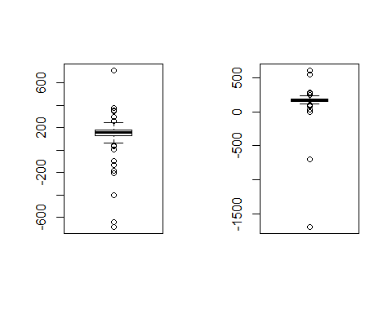

par(mfrow=c(1,1))  
bins <- seq(-1000, 2000, by = 100)  
boxplot(back_diff)

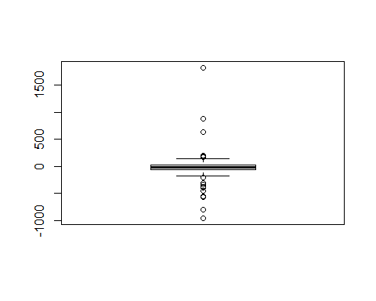

hist(back_diff, breaks = bins, main = "Lumbar Strength before and after training")

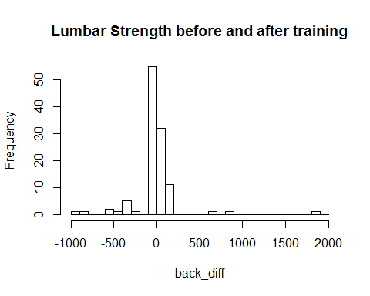

par(mfrow=c(1,2))  
min(post)

## [1] -1693.642

prepostBins <- seq(-2000, 2000, by = 250)  
hist(pre, breaks = prepostBins, main = "Lumbar Strength before training")  
hist(post, breaks = prepostBins, main = "Lumbar Strength after training")

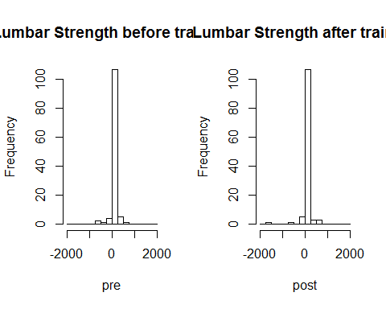

shapiro.test(pre)

##   
## Shapiro-Wilk normality test  
##   
## data: pre  
## W = 0.614, p-value = 2.778e-16

shapiro.test(post)

##   
## Shapiro-Wilk normality test  
##   
## data: post  
## W = 0.3874, p-value < 2.2e-16

shapiro.test(back_diff)

##   
## Shapiro-Wilk normality test  
##   
## data: back_diff  
## W = 0.6317, p-value = 6.565e-16

### Part 2d

Comment on the suitability of this data for the paired t-test, the Wilcoxon signed rank test, and the sign test.

### -|-|-|-|-|-|-|-|-|-|-|- Answer 2d -|-|-|-|-|-|-|-|-|-|-|-

There are a lot of outliers in the data and the shapiro test helped verify that the data is not normal. The values are also clumped in the middle of the histogram (a very steep and flat bell curve). A nonparametric test will be best to use with the data.

### Part 2e

Conduct an appropriate test to see if there is a difference in the central values for the pre- and post-training measurements for lumbar strength using $α=0.10$.

#### Step 1

Define the parameter in words in the context of the problem.

#### -|-|-|-|-|-|-|-|-|-|-|- Answer 2e.step1 -|-|-|-|-|-|-|-|-|-|-|-

A Wilcoxon Rank Sum will be used to test for differences in the median of lumbar strength before and after training with a lumbar strengethening device using alpha = 0.10.

#### Step 2

State the null and alternative hypotheses for the test.

#### -|-|-|-|-|-|-|-|-|-|-|- Answer 2e.step2 -|-|-|-|-|-|-|-|-|-|-|-

Null Hypothesis: There is no difference in lumbar strength before and after using the Lumbar Extension Dynamometer.

Alternative Hypothesis: Using the Lumbar Extension Dynamometer resulted in a difference in lumbar strength.

#### Step 3

Use R to generate the output for the test you selected.

#### -|-|-|-|-|-|-|-|-|-|-|- Answer 2e.step3 -|-|-|-|-|-|-|-|-|-|-|-

#Wilcoxon Sum Rank test  
wilcox.test(pre, post, conf.int = TRUE, conf.level = .90)

##   
## Wilcoxon rank sum test with continuity correction  
##   
## data: pre and post  
## W = 5270, p-value = 0.0003333  
## alternative hypothesis: true location shift is not equal to 0  
## 90 percent confidence interval:  
## -25.455346 -9.743686  
## sample estimates:  
## difference in location   
## -17.20705

#For the second part...  
wilcox.test(post, pre, conf.int = TRUE, conf.level = .95)

##   
## Wilcoxon rank sum test with continuity correction  
##   
## data: post and pre  
## W = 9130, p-value = 0.0003333  
## alternative hypothesis: true location shift is not equal to 0  
## 95 percent confidence interval:  
## 8.282338 27.297844  
## sample estimates:  
## difference in location   
## 17.20705

#### Step 4

State a statistical conclusion at $α=0.10$ and interpret it in the context of the problem.

#### -|-|-|-|-|-|-|-|-|-|-|- Answer 2e.step4 -|-|-|-|-|-|-|-|-|-|-|-

## Conclusion: Reject null hypothesis at alpha = 0.10. There is sufficient evidence to claim that the there is a difference in lumbar strength after using the Lumbar Extension Dynamometer (P = .0003).

### Part 2f

Write an interpretation in the context of the problem for a 95% CI.

### -|-|-|-|-|-|-|-|-|-|-|- Answer 2f -|-|-|-|-|-|-|-|-|-|-|-

## With 95% confidence, the population median for lumbar strength increased 8.3 to 27.3 [units] after using the Lumbar Extension Dynamometer for 10 weeks.